Digital Logic Lab 6 Report

Digital Logic 2116L

3/12/2018

Featheringill 210

Suyi Diao, Bryce

1. Introduction:

The basic concepts we learned for this lab are how to use 2-bit multipliers to assemble a multiplier in lab and how to link the output to LED lights in lab.

1. Design Requirements:

We need to link the 2-bit multiplier we produced in prelab part 2 to the LED lights produced in prelab part 1 to get a gadget that correctly calculates 2-bit numbers multiplications and display the output to the LED lights.

1. Diagrams

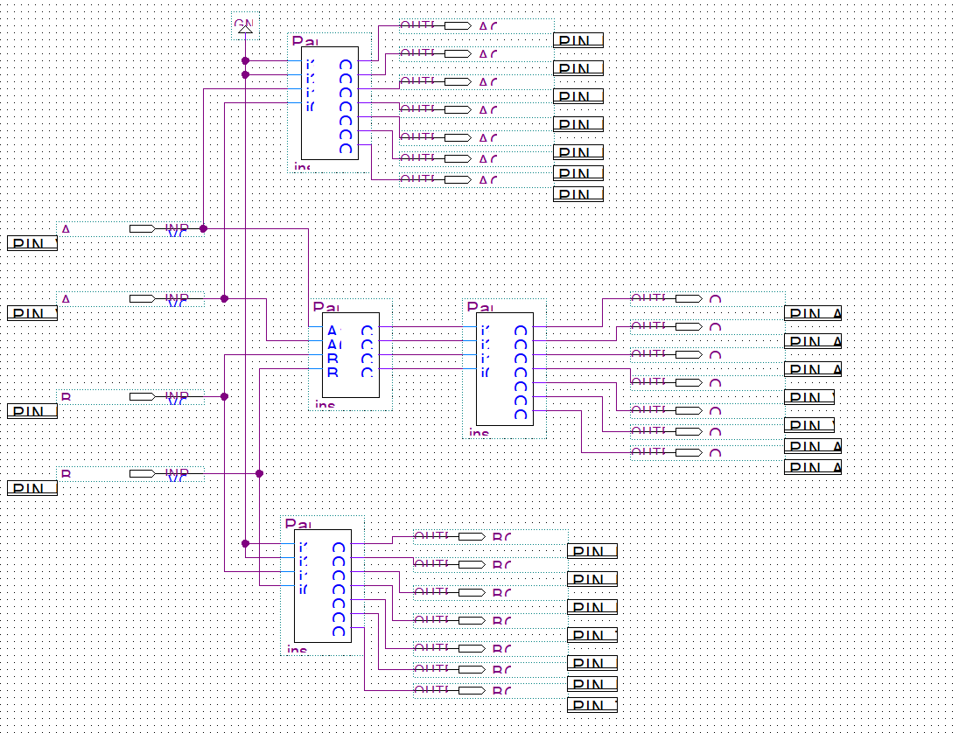

1. Results

Using the control on the mother board, we can now perform multiplications within 3, positively shown on the LED lights.

1. Discussion

Everything in the lab runs smoothly, we did the prelab and the implementation process to the board took some time

1. Conclusion

In this lab, I learned about the power of reusability of schematics and the wonderful things they can achieve. The LED works perfectly as I would never expect, but they did, so yay.

1. Post-Lab Questions

